Advertising Age November 29, 1999
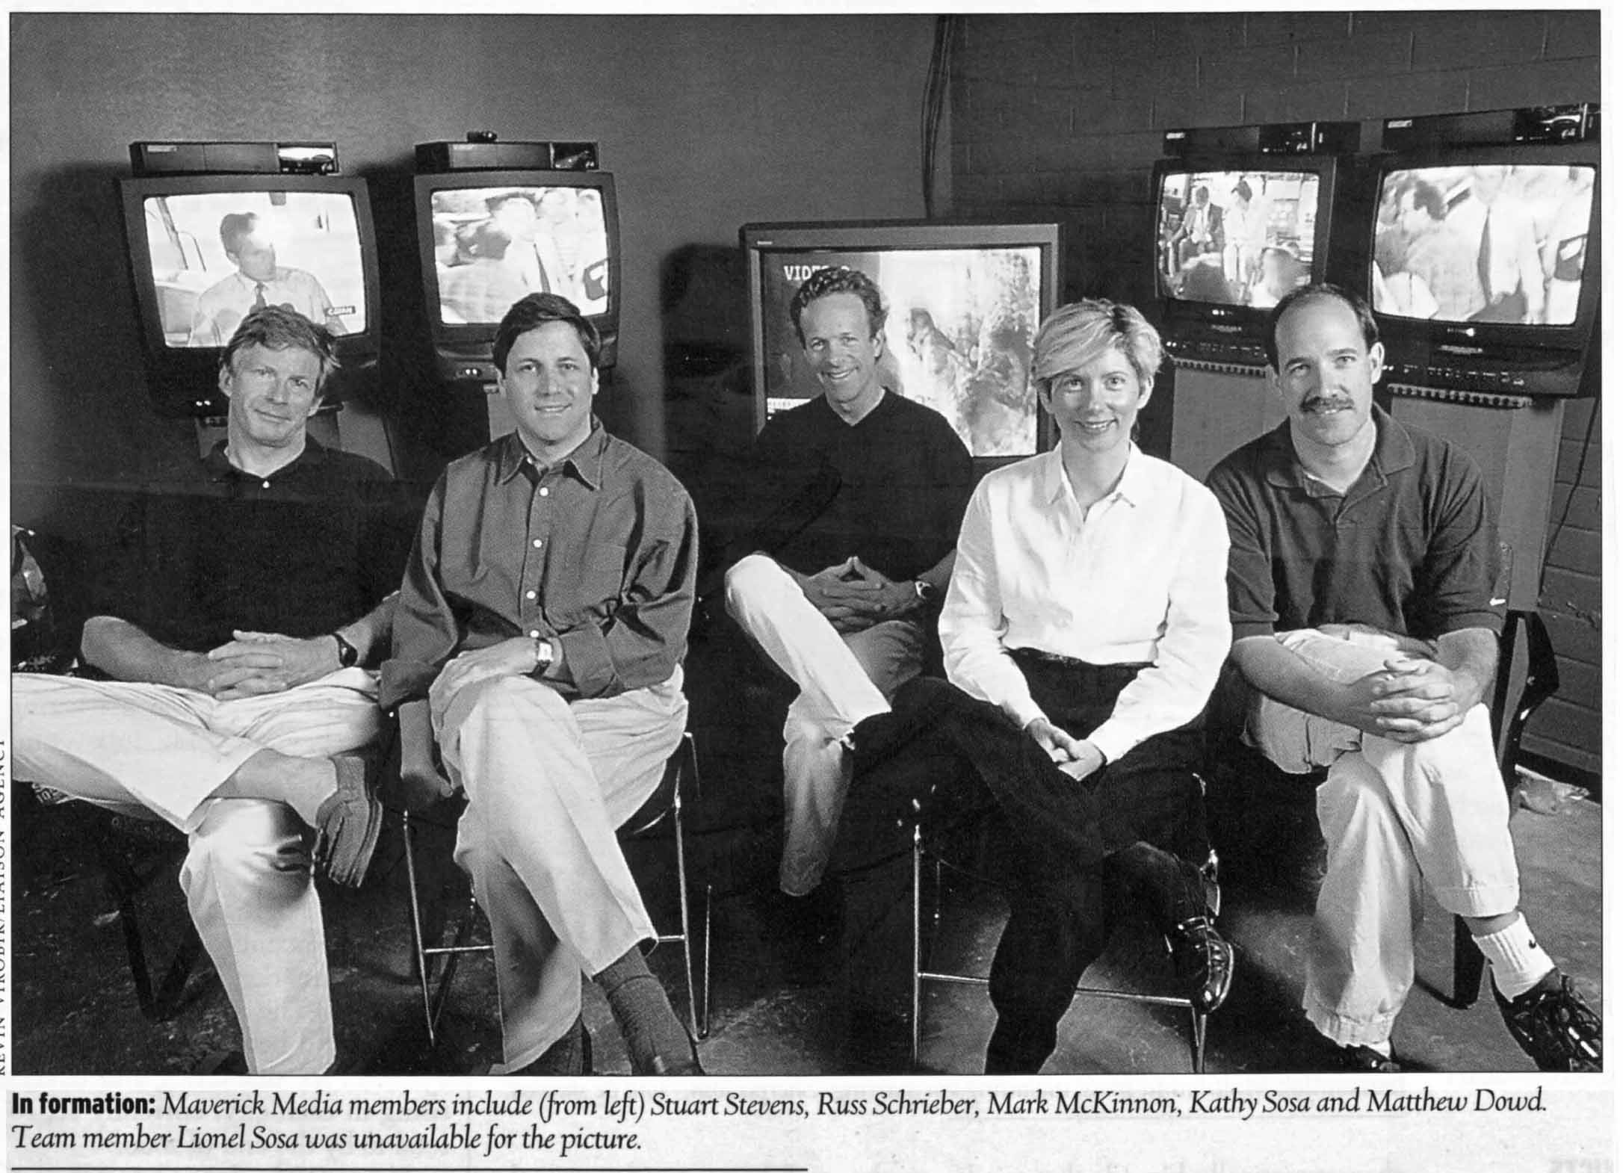Eclectic execs aren't bush league
By Ira Teinowitz

[Austin, Texas] Mark McKinnon moved to Texas after winning a song-writing contest and composing for Kris Kristofferson's label. Stuart Stevens wrote a book, "Feeding Frenzy," about trying every three-star Michelin restaurant in Europe, one a day, all in a row. Lionel Sosa has a Web site featuring his paintings.
George W. Bush may be the front-runner in the GOP presidential derby, but his Maverick Media seems to have already won any race for campaign ad team members with eclectic backgrounds.
Forget the office, where the campaign's ads are produced and edited in a former bomb shelter with walls painted tomato-sauce red, and completed with big cans of food and old gun cases from the nearby Army surplus store. Just look at the people.
TEAM ROLL CALL
Mr. McKinnon, 44, who heads the core six-member team, saw his bid for immortality dashed abruptly when Elvis Presley, who he said had agreed to cut his "Deserted Island Blues," died before making the record.
Mr. McKinnon instead became editor of the University of Texas Daily Texan, then a spokesman for Texas candidates and, later, a political consultant. His agency work includes a short stint at the shop then known as Sawyer-Miller Group in New York, and a longer one in the Austin agency Public Strategies.
All of the candidates he backed were Democrats, putting Mr. McKinnon in a "Who's Who" of that party's media consultants that includes Paul Begala, James Carville, Dick Morris and Mandy Grunwald. The candidates included several Texas governors-and in the Empire State stint, onetime presidential hopeful Michael Dukakis.
When he quit the campaign trail in 1996, Mr. McKinnon wrote a piece for Texas Monthly complaining about politics' growing partisanship and meanness. While he wrote he could still work for a few candidates who don't practice "the politics of division . . . I won't miss desperate candidates, manic campaign managers and last-minute attack and response ads."
He continued to advise companies at Public Strategies and he also produced a documentary about a unique Houston school. That documentary led to a conversation with Mr. Bush, who Mr. McKinnon met at Austin social events. The meeting prompted Mr. Bush, a proponent of charter schools, to actively promote the Houston school, and ultimately led to a friendship. Two years ago, Mr. McKinnon signed to head the ad team for Mr. Bush's gubernatorial campaign, and elected to stay for the presidential race.
"I was struck when I met him, because I had a Democratic mythology [with perceptions drawn] from drinking Democratic Kool-Aid for years," said Mr. McKinnon. "I was instantly struck by how different he was . . . deeply thoughtful and substantive and compassionate.
"The one thing I did discover in the arc of my political career is that character is far more important than ideology and that people with good character will make sound judgments. In his decisionmaking, [the governor's] first instinct is to ask what the right thing is to do, not what is the political thing to do. He is not an ideological hostage."
STATISTICS WHIZ
Matthew Dowd, 38, the whiz at statistics and coordination who signed on this year to run Maverick Media's day-to-day operations, oversees media buying and tracks research. He is also part of the creative team. After seeing Public Strategies-the agency he co-founded to deal with campaigns and public policy issues-grow from four people to 116 people in a decade, Mr. Dowd decided to bow out. Two months later, he joined his former partner in working for Gov. Bush.
Then there is Lionel Sosa, 60, the president-CEO of Hispanic agency Garcia LKS, San Antonio, and an artist who displays his work on the sosartshow Web site. After toiling in some Texas GOP campaigns in the late 1970s, he aided Ronald Reagan's Tuesday Team in 1980 and 1984 with Hispanic ads, and then went on to support Gov. Bush's father. Two years ago, Mr. Sosa, along with his wife, Kathy, the 46-year-old creative director of Garcia LKS, joined Mr. Bush's gubernatorial campaign. Both are involved in the current campaign too, though this time they are working on non-Hispanic spots as well.
DOLE VETERANS
Finally, there are Mr. Stevens, 47, and Russ Schriefer, 41, partners in the political ad firm of Stevens & Schriefer, Alexandria, Va.
Mr. Stevens has written episodes for "Northern Exposure" and "I'll Fly Away" and several books, but in political advertising circles he is a heavyweight GOP ad executive. Four years ago, Messrs. Stevens and Schriefer handled Bob Dole's primary election campaign, one of a large number the duo has been involved in.
Mr. McKinnon said it was the team's ads for Pennsylvania Gov. Tom Ridge's two campaigns (the last in 1998), their GOP background and their willingness to move to Austin that convinced him-after interviewing a dozen GOP ad teams-to ask Messrs. Stevens and Schriefer to join. He also said he felt no pressure from others in the campaign or Gov. Bush himself to sign on some GOP ad executives; he simply felt he could use the aid.
"I felt we needed more muscle," said Mr. McKinnon, adding that their work "doesn't seem political."
LAST CAMPAIGN
Mr. Stevens said his motivation to move temporarily from New York and participate in the Bush campaign was fueled by a suspicion that the coming year may be his last as a political adman.
Mr. McKinnon never considered enlisting Madison Avenue executives extensively in the Bush team. In the article about getting out of politics he described them as one horror of the Dukakis campaign.
"Dukakis decided that rather than using political media consultants, he'd get experts at commercial advertising. The problem we quickly discovered is that Madison Avenue can sell the hell out of soap, but when it comes to political campaigns they're as useful as bicycles to fish," he wrote. "They think style, not substance; form, not content. Political media consultants are used to producing ads in 24 hours for $5,000. These folks couldn't imagine producing anything for less than $200,000, and if it had been left to them most of the ads would have been ready just in time for Christmas."
His feelings haven't changed much. "There was chaos," he remembered. "All these talented people in a fast-moving campaign. Trying to coordinate was very difficult."
He suggests that the same problems may face Democratic candidate Bill Bradley, who has opted for a Madison Avenue team.
"Having 16 alpha dogs in a campaign is asking for trouble," said Mr. McKinnon.
COLLEGIAL EFFORT
The Bush team's background may be unusually diverse, but the group is producing ads as a collaborative, collegial effort, batting ideas around, swapping scripts, looking at tape often shot by Mr. McKinnon himself using a Canon XL1 digital camera at campaign events. Only the media buying, handled by National Media in Alexandria, Va., is away from Austin.
"I know it sounds implausible, but it is totally collegial," said Mr. McKinnon. "Nobody is a copywriter. Nobody is a creative director. Nobody is the director. When I say we need a new education spot, I e-mail everyone and then we all fingerpaint."
The collaboration extends to the campaign itself. Though in a separate Austin building, Mr. McKinnon works closely with campaign strategist Karl Rove in an unusually tight decisionmaking structure where ads are reviewed by just three or four people.
"We don't have to go through layers of committees and bureaucracy to get decisions made," he said. "This is a candidate who is very clear about what he wants to say, so there is not a lot of navel-gazing. We know what the governor wants to say. We've known for months. The execution is where there has been some latitude and we are given free rein."
BOUNCING AROUND
Mr. Stevens noted that's a far cry from the Dole run of four years ago, when the media team bounced between Washington campaign headquarters and the New York production studio, amid internal squabbling within the campaign. He credits Messrs. McKinnon and Rove for creating a productive culture.
He goes even further, suggesting that Vice President Al Gore's recent move of his campaign staff to Nashville is "an attempt to emulate what grew up naturally here."
Mr. Dowd said Gov. Bush is comfortable with and used to Mr. McKinnon from the governor's race and so doesn't engage in second-guessing. Mr. McKinnon agrees.
"The governor understands that there are going to be bumps in the campaign and that this is a marathon, not a sprint. So when the inevitable occurs and you lose altitude and someone else gets on the screen, this is a campaign that is not going to be easily spooked," he said. "The campaigns that lose are those that abandon their strategy when trouble sets in."
The Bush ad team has been working for months, and its ad strategy laid down in June so far hasn't changed much, said Mr. McKinnon. The biggest surprise so far is the lack of attack ads from rival Steve Forbes. Anticipating Mr. Forbes would ape his election strategy of four years ago, the Bush media team wrote and produced three responses to likely areas of attack-but so far hasn't used any of them.
Instead, after a quick introduction of Gov. Bush in one spot, Maverick Media quickly launched into issue ads about military spending, education, and in its most notable ad to date, about returning the White House to a place children can look up to-a thinly veiled reference to President Clinton's affair with Monica Lewinsky.
"The one great asset we have is the Bush name," said Mr. McKinnon. "It has great brand equity. What people associate and attribute to the name Bush is honesty, integrity, loyalty and character. We are in the fortunate position of building on that brand."
ADS TO RUN EVERYWHERE
Mr. Dowd said the campaign's strong financial position will allow running ads everywhere, and the ad team plans to take advantage of that in GOP states with early primaries and caucuses. "We will be up everywhere before Christmas," he said, though adding that there are no plans for national buys like those placed by the Forbes campaign on some cable networks.
Moving up the primary and caucuses has caused one change from four years ago. Facing only three weeks after the Christmas holidays compared to six weeks of four years ago, the Bush campaign faces the prospect of having to get its message out earlier.
Mr. McKinnon wouldn't disclose overall media strategy, but said TV would support the bulk of the Bush campaign, with print and radio carrying some Hispanic and specialty messages.
While the ad team is squarely in the Bush camp, that's not to say they haven't had differences in the past.
Mr. Schriefer, who served as New York campaign manager in 1987 and 1988 for Gov. Bush's father, remembers an unusual first meeting with the younger Mr. Bush during a three-day road trip to help line up delegate candidates.
"We drove for three days around New York state, and he kept pressing the radio buttons and complaining about the lack of country music stations," said Mr. Schriefer, who hastily adds he doesn't mind listening to country music "when I am in Texas."

